**Spinner Application Overview**

**Introduction**

The Spinner application was designed to fill a niche gaming market: social and party games that attract users in the 12-24 age bracket, allowing a wide variety of individuals to play with friends in an engaging and cooperative manner. The game is designed in a way that encourages users to spread the application by word of mouth, alleviating a need for advertising expenses to proliferate user familiarity with the brand. If one user is in a social engagement and recommends challenging a friend to play against them, the friend will be directed to download the application and partake in the fun. An absence of profanity or mature themes means the application can be used by a wide range of audiences, and the simplistic nature of the game rules allow for any user to quickly adjust and participate.

The gameplay is straight forward: invite your friends to join a matchmaking lobby, initiate the game, and wait for on-screen instructions. The instructions will indicate a cardinal direction to rotate the phone towards, and each time the user successfully turns in this direction they are awarded a single point. The user is encouraged to turn their entire body towards the given direction for maximum mobility, which adds an additional layer of excitement to the gameplay: dizziness and disorientation. This enables a humorous aspect that makes Spinner perfect for playing with friends in a social gathering. At the end of each game, the individual with the highest point total is indicated as the winner, and their high score is subsequently updated as necessary.

**Market Research**

There are several games on the app store that cater to the demographics and setting that Spinner is being directed towards. The most notable of these is *Heads Up!*[1] developed by Warner Brothers International Enterprises, which focuses on using the phone as a playing card which displays a famous individual or location. The other players must shout out information that suggests what the phone is displaying without the user viewing their own screen. This application requires group participation, but unlike Spinner, it does not encourage other players to download the application on their own device to participate in competitive multiplayer. *Heads Up!* similarly fails to allow for single-player gameplay, while Spinner allows for users to test their abilities in a private game room. Finally, *Heads Up!* can be played in a stationary position while Spinner recommends that users actively spin their bodies to accumulate point totals.

With these aspects considered, Spinner could proliferate the market through a variety of unique characteristics: analogous multiplayer and single-player gameplay, encouragement of physical activity, public leaderboards of high scores, and a competitive environment that allows players to strive to achieve greatness. Few applications combine these components together with a seamless integration, but Spinner successfully does so.

**Development Timeline**

Development of Spinner began in early July with an initial commit of the core Android file structure, and development steadily increased in frequency with a peak commit frequency around July 10th. Activity steadily decreased from that point, with another peak of development near the end of July. Initial commits were focused on establishing activity frameworks for the main menu, sign up, and sign in pages. Account-related pages were directly connected to a back-end Firebase database which stored all relevant user information in real-time rows.

Around mid-July during peak development the remainder of the application was being developed and tested. The leaderboard was perfected, gathering data from the Firebase to publish all relevant user high scores, and the game logic was fleshed out and polished. The latter end of July was focused on additional application polishing, where many activity layouts were redesigned from relative or linear layouts to constraint layouts. To allow for seamless application appearance, all buttons and text forms were designed to be the same size at the same relative positions on the screen, giving users the opportunity to familiarize themselves with where components were expected to be displayed.

The second phase of project development began near the end of July, where additional functionality was added to the application. Work was performed on integrating a chat system between signed in users, as well as reformatting some of the existing components such as the leaderboard and game activity. Some additional polish was performed on the multiplayer functionality, circumventing existing bugs and allowing for cleaner group gameplay.

**Implemented Features**

The application is broken into single-player and multiplayer modes, both of which operate using the same game activity and logic. Multiplayer is simply engaged using a bundle of information regarding which two players are against one another, while the single-player mode begins without a bundle. The application sign in and sign up process utilized the Firebase account features, and all the relevant user information is stored in a real-time Firebase database. All layouts were designed using constraint layout to make the appearance of activities as flexible and cohesive as possible, and a custom button design and application color palette were used to give the game additional personality.

**Future Development**

Although there was a desire to incorporate Fragments into a FragmentLayout and streamline the design around them, the entire code base was designed using activities that were independent from one another. The amount of time necessary to refactor the code into organized fragments seemed like a trade that would not yield a notable increase in efficiency.

The limitations of the Firebase database made it difficult to incorporate a lobby system that allowed for multiple users to join at the same time. To circumvent the problem of identifying which users would like to participate in which game lobby, the application was reconfigured to use a simple matchmaking process. Individuals would instead wait in a lobby until another user is ready to join, at which point they would automatically begin playing against one another.

Both of these planned features could be incorporated in the next iteration of the design, along with other planned features that could not make it into this version: avatar uploading and on-device storage of user login status.

**Application Layout and Flow**

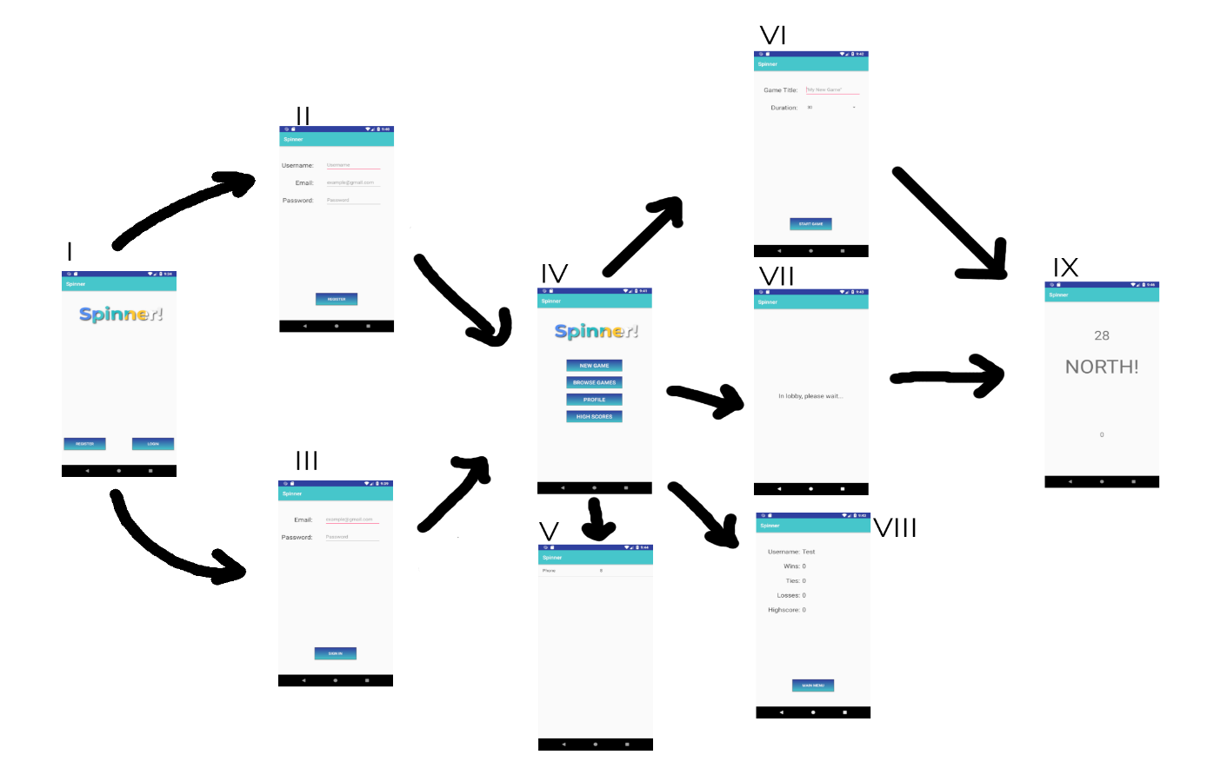

Figure 1: Application Layout

I (StartActivity), II (SignUpActivity), III (SignInActivity), IV (MainActivity), V (LeaderboardActivity), VI (NewGameActivity), VII (GameBrowserActivity), VIII (ProfileActivity), IX (GameActivity)

**Conclusion**

Spinner has the potential to reach an audience that is extremely abundant in the Android marketplace, while catering to niche situations that presently have few applications in the playing field. The present features make the application an exciting addition to any social gathering, allowing friends to challenge one another to quick 30-second matches involving quick spinning and mind-boggling disorientation. While challenging in a multiplayer environment, the rules are inclusive and simplistic enough for anyone to easily pick up and play the game. The game allows for growth into advertising revenue streams with ample space for the addition of in-game banners that would not impede or distract from the gameplay. All in all, with additional polishing and the inclusion of some new features, the application is very close to reaching a point where it could be marketed to the intended audience.

1. https://play.google.com/store/apps/details?id=com.wb.headsup